***NAME: AHSAN SAJJAD***

***Enrollment: 02-131212-049***

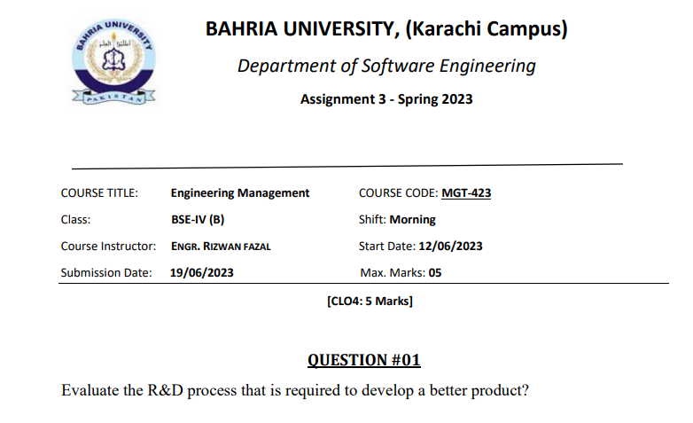

***Evaluation the R&D Process for Developing a Better Product:***

**Introduction:**

Innovative and better products are made possible by the research and development (R&D) process. The main objective of this evaluation is to rate the importance of the R&D process' essential components in creating better products. We may assess the R&D process' effectiveness and efficiency in promoting product innovation by comprehending and evaluating each stage.



1. **Research Phase:**

The R&D process is built upon the research phase. In order to pinpoint client demands, market trends, and possible possibilities, rigorous market research and analysis are required. This phase enables R&D teams to connect their efforts with market demands by acquiring pertinent data and insights, resulting in the creation of a product that fills in current gaps and provides a competitive edge.

1. **Idea Generation:**

After the research phase, the idea generation step entails generating and conceptualising suggestions for new products and enhancements. This stage promotes innovation and a culture that values various points of view. A wide range of potential solutions are ensured by effective idea generation, stimulating innovation and raising the possibility of creating a better product.

1. **Feasibility Analysis:**

A feasibility analysis is done to assess the technical, financial, and operational viability of numerous ideas after they have been produced. In this step, the resources needed, technological viability, market potential, and potential hazards related to each idea are evaluated. The feasibility study aids in selecting the concepts that have the best chance of succeeding and offers useful information for decisions about further development.

1. **Prototype Development:**

A crucial step in the research and development process is prototyping, where chosen concepts are turned into real-world product models. Testing and validation of design concepts, functions, and performance are made possible through prototypes. Iterative prototyping assists in finding and fixing defects, resulting in the improvement and improvement of the product. During this phase, user feedback and usability testing are extremely helpful in creating a better product.

1. **Testing and Evaluation:**

Prototypes are thoroughly examined throughout the testing and evaluation stage to determine their effectiveness, level of quality, and user happiness. Alpha and beta testing, reliability testing, and performance evaluation could all be a part of this step. The discovery and correction of technical faults are made possible by thorough testing and assessment, guaranteeing that the finished product meets or exceeds client expectations.

1. **Iterative Refinement:**

The research and development team iteratively improves the product's design, functionality, and performance based on the findings of testing and assessment. The iterative refinement cycle enables the product to be continuously improved and optimised. The process of refinement is regularly guided by feedback from stakeholders, customers, and market developments, improving the product's overall quality and competitiveness.

1. **Scale-Up and Production:**

The R&D process moves into the scale-up and production phase when the product design has been optimised. This entails ensuring the production process is scalable and economical, choosing suitable suppliers, and putting in place quality control procedures. In order to efficiently provide the upgraded product and satisfy market demand, a smooth transition from the R&D phase to manufacturing is essential.

**Conclusion:**

"The research and development process are a methodical, comprehensive strategy for creating superior products. The quality, functionality, and competitiveness of the final product are improved at every stage of the R&D process, including research, concept generation, feasibility analysis, prototype development, testing and assessment, iterative refinement, and scale-up. Organizations may maximize their efforts, reduce risks, and provide cutting-edge products that meet or exceed consumer expectations by adhering to a well-defined R&D process.”

